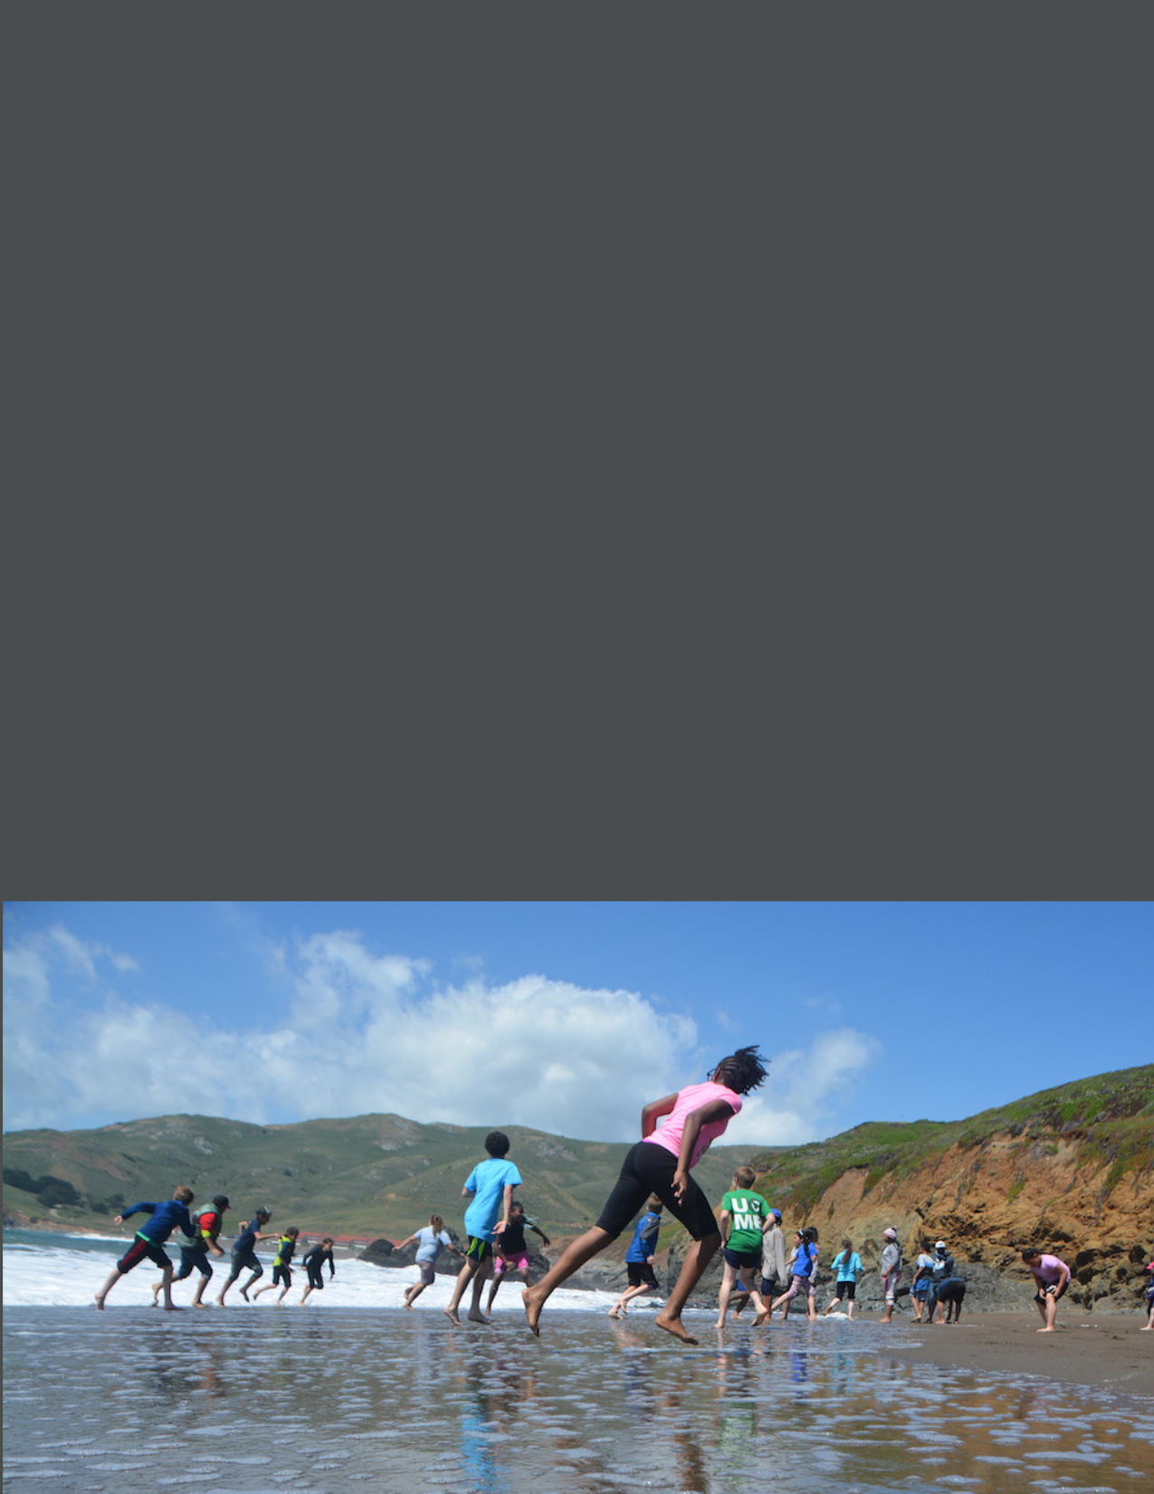
Explor
State Coastal Conservancy Grant Application Guide

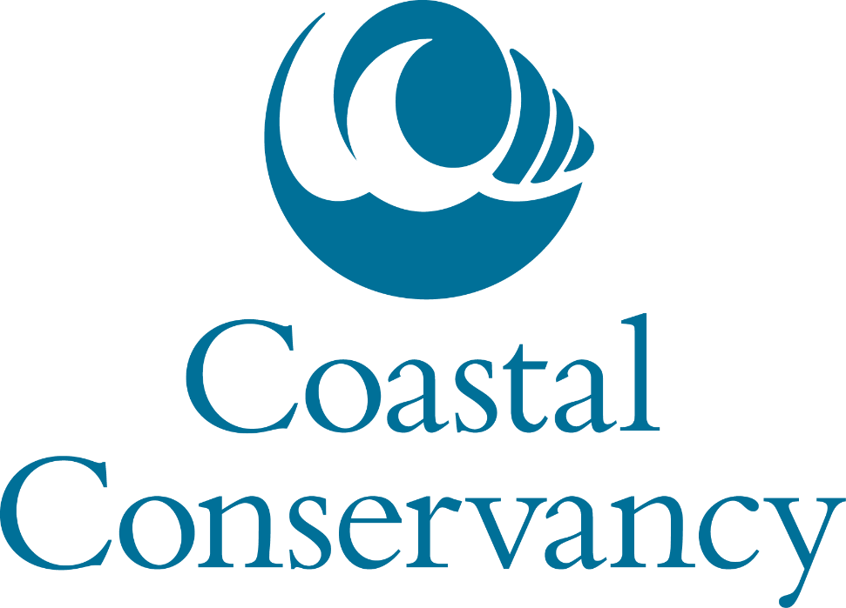
GRANT APPLICATION GUIDE
Released October 2022

Application is a separate document found at this link.
Submit Application via email to grants@scc.ca.gov
Contents
State Coastal Conservancy 3
Mission Statement 3
Foreword 3
Contact Information 3
Key Links 3
Purpose of Application Guide 4
I. Grant Program Overview 5
Intent 5
Eligible Applicants 5
Eligible Projects 5
Grant Amount Per Application 5
Application Deadline 6
Application Process 6
Grant Administration Process 7
PHOTOS AND RECORDS SUBMITTED WITH APPLICATION 9
II. Application Package 10
Application Checklist 11
Summary Information 12
Project Description 14
Project Selection Criteria 16
Tasks and Schedule 22
Project Cost Estimate 25
Project Maps, Design Plans, and Photos 28
Non-Profit Applicant Documentation 28
Conservation Corps Consultation Process 29
Southern California Wetlands Recovery Project 29
Grant Application Survey 29
III. Eligible Costs 30
Acquisition Project Eligible Costs 30
Planning Project Eligible Costs 30
Implementation Project Eligible Costs 31
Ineligible Costs 32
IV. Appendices 34
Technical Assistance for Applicants 34

State Coastal Conservancy

Mission Statement
The State Coastal Conservancy’s vision is of a beautiful, restored, and accessible coast for current and future generations of Californians. We act with others to protect and restore, and increase public access to, California’s coast, ocean, coastal watersheds, and the San Francisco Bay Area.

Foreword
The State Coastal Conservancy (“Conservancy”) is a state agency established in 1976 to work proactively with local communities to implement multi-benefit projects that protect and enhance coastal resources. The Conservancy works along the entire length of California’s coast, within the watersheds of rivers and streams that extend inland from the coast, and throughout the nine-county San Francisco Bay Area.

The Conservancy is committed to providing technical assistance and being approachable and informative. Contact information is listed below, and grant updates can be found at: https://scc.ca.gov/grants/.

Contact Information
Regional Manager Contacts  North Coast: Del Norte County to coastside Sonoma and Marin Counties  Karyn Gear: karyn.gear@scc.ca.gov  San Francisco Bay Area: Nine Bay Area Counties, excluding the coastside of Sonoma, Marin, and San Mateo Counties  Moira McEnespy: moira.mcenespy@scc.ca.gov | Central Coast: Coastside San Mateo County to Santa Barbara County  Trish Chapman: trish.chapman@scc.ca.gov  South Coast: Ventura County to San Diego County Megan Cooper: megan.cooper@scc.ca.gov

Key Links

Application
- Application download in Microsoft Word – found at this link: https://scc.ca.gov/webmaster/ftp/pdf/forms/SCC_Grant_Application.docx
If you do not have Microsoft Word, please open the file in Google Docs and fill out the application, then save it as a Microsoft Word document before submitting.

Website
https://scc.ca.gov/grants/

Purpose of Application Guide
This application guide provides step-by-step instructions on completing a grant application for the Conservancy. Use this guide as you go through your application to help answer questions and provide the appropriate information.

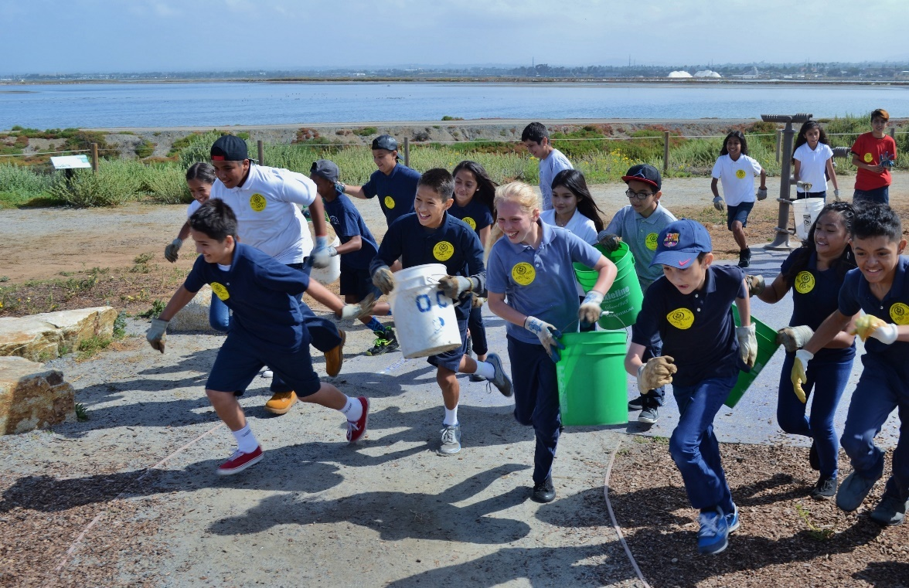

Grant Program Overview

Intent
The Conservancy’s grants will fund projects that support our Strategic Plan (found at this link: https://scc.ca.gov/about/plan/ ) and meet our Project Selection Criteria (found at this link: https://scc.ca.gov/grants/project-selection-criteria-2/). There are no program-specific priorities or funding limits, and applications will be accepted on a rolling basis.

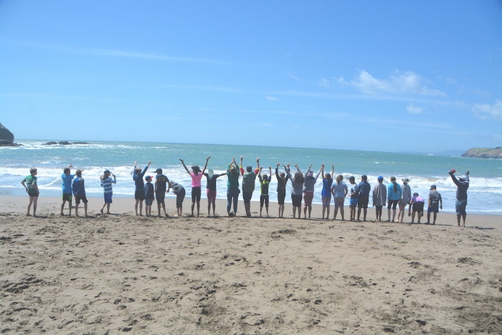

Eligible Applicants
- Public Agencies, including Joint Power Authorities and Federally-Recognized Indian Tribes
- Nonprofit organizations with 501(c)(3) status
- Other community-based organizations and non-federally-recognized tribes may apply with a 501(c)(3) fiscal sponsor

Eligible Projects
- Types of eligible projects
  - Develop plans and permits for projects that meet the funding priorities below
  - Implement projects that meet the funding priorities below
  - Acquire property that furthers the funding priorities below.
- Funding priorities
  - Projects that meaningfully advance one or more the of the Conservancy’s Strategic Plan objectives

For details on eligible costs, please see the Eligible Costs section.

Grant Amount Per Application
There are no maximum or minimum grant amounts for this funding; however, it is anticipated that most grants will be between $200,000 and $5,000,000.

Application Deadline
Applications may be submitted on a rolling basis and will be accepted and evaluated when they are received.

Application Process
The application is a two-step process. Applicants will first submit a pre-application. If a pre-application meets the Conservancy’s Eligibility Criteria and there is available Conservancy funding for the project, applicants will be invited to submit a full application. Here are the steps in the application process:

Develop a Pre-application
- If needed, request a technical assistance consultation with the Regional Manager covering your project area to discuss project eligibility. All applicants are encouraged to request this consultation prior to pre-application submission. See page 3 for details on how to contract the Regional Manager.
- Submit a Pre-application, which can be found at this link: https://scc.ca.gov/webmaster/ftp/pdf/forms/SCC-Grant_Pre-Application.docx
- Within 60 days, you will receive notification whether you are being asked to submit a full application or if your project is not eligible for Conservancy funding.
- If your project is selected for a full application, go to step 2 below.

Develop a competitive full application
Prior to full application submission, we recommend applicants:
- Review this Application Guide to understand the requirements in more detail.
- Review the following materials for grantees on the Conservancy website to understand standard grantee requirements if your application were to be selected for funding.
  - Grantee Manual: https://scc.ca.gov/grants/grantee-manual/
  - Typical Grant Agreement Terms: https://scc.ca.gov/webmaster/ftp/pdf/forms/typicalgrantagreementterms.pdf

Submit your application
- Email the application to the Conservancy at grants@scc.ca.gov. Application submittal instructions are found on page 10.
- After you have submitted your application, we ask that you fill out this anonymous short survey: https://www.surveymonkey.com/r/3TLJBYK. Your input will help us improve our grant application process in the future.

Conservancy review of application
- You may be asked to correct or complete documents after the application is submitted.
- Conservancy staff will evaluate applications based on the Project Selection Criteria.
- You may be invited to provide additional information to Conservancy staff during the application review process.
- You may be asked to participate in an Application Interview and/or site visit to provide additional information to Conservancy staff during the application review process.

Grant approval process
- Grant award recommendations will be announced approximately 60 days after the application is received. You will receive an email indicating whether or not your application will be recommended for a grant award. All grants must be approved by the Coastal Conservancy Board.
- After Grant award recommendations are made, you may request feedback from Conservancy staff on strengths and weaknesses of your application.
- Applicants who receive a grant award letter will be assigned a Conservancy Project Manager to work with.
- The Conservancy Project Manager will present a recommendation for funding to the Coastal Conservancy Board. Applicants may be asked to provide materials to assist in making this recommendation. If the Coastal Conservancy Board approves the Grant recommendation, the Conservancy Project Manager will move forward with the Grant award.

Grant Administration Process
The Conservancy’s grant administration process is explained in detail in our Grantee Manual, which can be found at this link: https://scc.ca.gov/grants/grantee-manual/. An overview of the grant process is provided below.

- Following approval by the Coastal Conservancy Board, the Conservancy Project Manager will send a Grant Agreement to the applicant along with a link to the Grantee Manual. Refer to the Grantee Manual (https://scc.ca.gov/grants/grantee-manual/) for further detail.
- After a signed Grant Agreement is returned and signed by the State, the applicant becomes a Grantee.
- The Grantee must then complete the Conditions Precedent to Project Commencement listed in the Grant Agreement, which include but are not limited to submitting a Work Program for Conservancy approval.
- Work on the grant may begin only after receiving a notice from the Conservancy Project Manager that all of the Conditions Precedent to Project Commencement have been met.
- Project Completion Date is at least three months before the end of the Grant Termination Date.
- Send the final payment request to the Conservancy at least two months before the Grant Termination Date. This gives time for the Conservancy to review the payment documents, conduct a final site inspection, and process the final payment through the State Controller’s Office.

Your tasks
SCC tasks

PHOTOS AND RECORDS SUBMITTED WITH APPLICATION
All information that you submit is a public record subject to disclosure under the Public Records Act.

Please indicate if photos, maps, or other material submitted with this application require crediting when reused by the Conservancy - you should indicate this on each document.

If you provide any photographs of individuals to the Conservancy, you should ensure that the individuals (or the guardians of individuals under the age of 18) were informed that photographs may be taken and used for any non-commercial purpose.

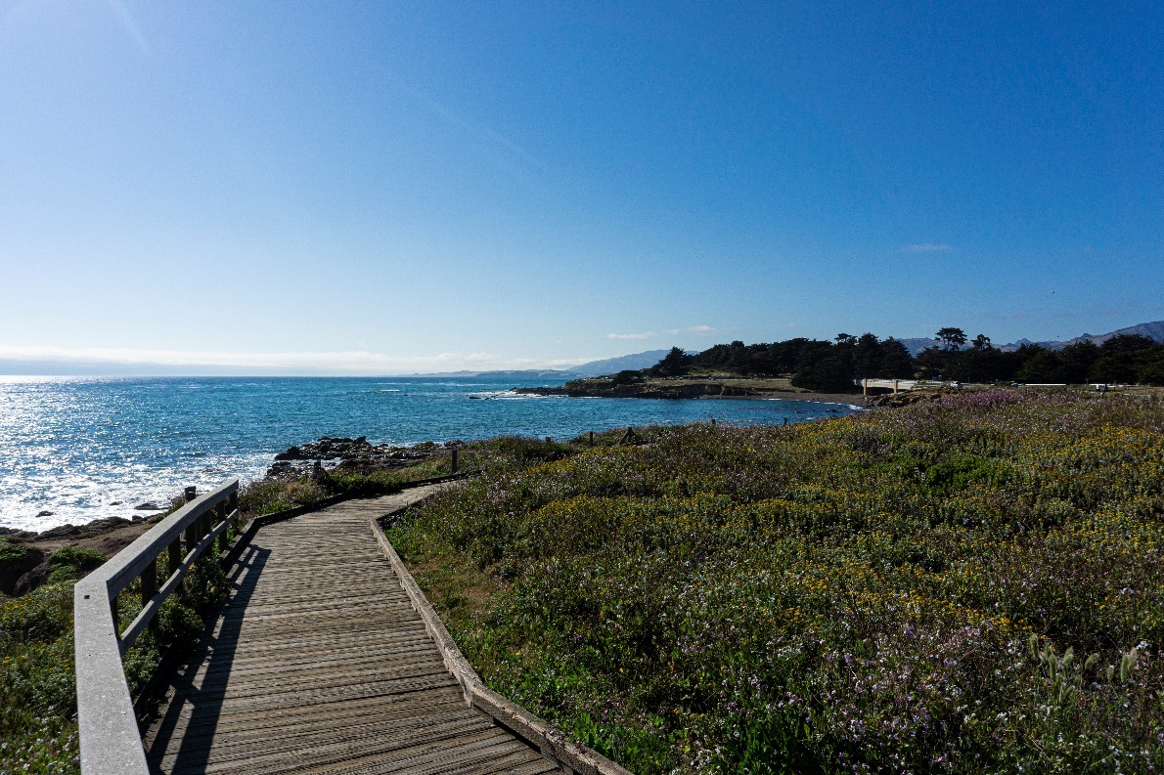

Application Package
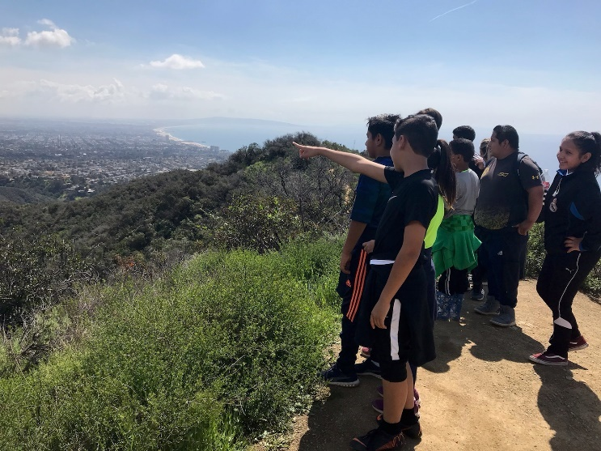
This section provides detailed guidance to complete the application.

Please follow these five instructions to prepare the application.

- Use the Application Checklist on the next page to organize the application.
- Checklist items 1-6 are required for all applications.
- Checklist item 7 is only required for non-profit applicants.
- Checklist Item 9 is only required for projects that are on the Southern California Wetlands Recovery Project (WRP) Work Plan.
- Checklist item 8 is required for Implementation projects.
- For application submittal
  - Submit the application by email to grants@scc.ca.gov.
  - Do not mail a paper copy of the application.
  - Send only the items requested in the Checklist. Do not send supplementary materials, such as PowerPoint presentations or letters of support.
- Please keep at least one copy for your records.

Application Checklist
Use the checklist below to help you track completion of the required parts of the application. Directions for each item can be found on the page number listed below.

 | Application Item | Guidance Page Number
☐ | - Application Cover Sheet
☐ | - Project Description
☐ | - Project Selection Criteria
☐ | - Project Tasks and Schedule
☐ | - Project Cost Estimate
☐ | - Project Maps and Design Plans
☐ | - Nonprofit Organization Documentation
☐ | - For Implementation projects, applicants must submit a Conservation Corps Consultation Review Form.
☐ | - Southern California Wetlands Recovery Project (WRP) Work Plan support letter and map from Marsh Adaptation Planning Tool, if applicable.

Summary Information
Fill out the two-page summary information section provided in the application. Summary information should be no more than two pages.

CONTACT INFORMATION
- Organization. Be sure to enter your organization’s full legal name. If an applicant will be using a fiscal sponsor, the organization should be the fiscal sponsor, not the applicant.
- Contact Person. This should be the person who can best answer questions about the proposed project. The phone and email address provided should be for this person.
- Webpage. Please provide a link to your organization’s webpage, if you have one.

PROJECT INFORMATION
- Project Name. We recommend that the project name be no more than six words long. Pick a name that captures the essence of the project and the location if possible.
- Project Summary. Provide a one sentence description of your project that specifies 1) the phase of the project (Acquisition, Planning, or Implementation) 2) the key action of the project (develop a plan, restore wetlands, build a trail, etc), 3) the location, and 4) the number of acres or miles involved.
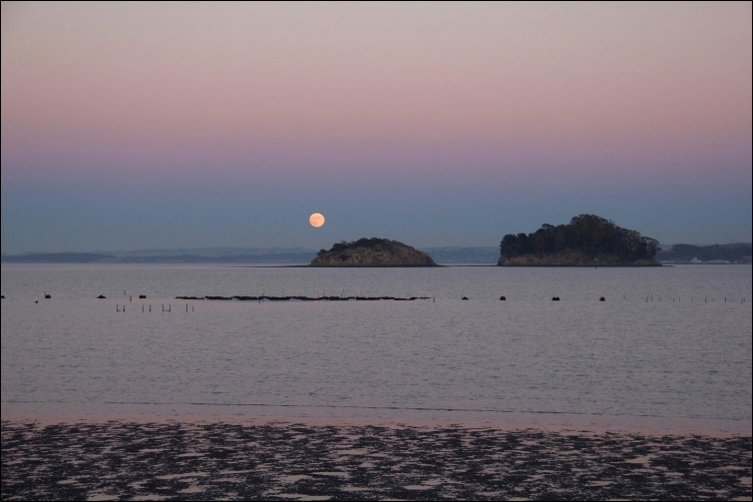
- Amount Requested and Total Project Cost. Provide specific numbers, rounded to the nearest one hundred dollars. Your answers should not be a range. We understand that the total project cost is an estimate and may change.
- Estimated Start and End Dates. Provide your best estimate of when work under the grant would start and when it would be complete. Your answer should not be a range. We understand that the dates are an estimate and may change.
- Project Type. The Conservancy can fund each phase of a project – Acquisition, Planning, and Implementation. But typically we would fund each phase as a separate grant with a separate application. We cannot fund the Implementation phase of a project until environmental review pursuant to the California Environmental Quality Act is complete (see CEQA Compliance section below). For this reason, we cannot fund both the preliminary Planning and Implementation phase of a project under one grant, unless the entire project falls within a CEQA exemption.
- Total Acres. For Acquisition projects, provide the total acreage of the property or easement that would be acquired. For restoration projects, provide the total acreage of the restoration area only.
- Total Miles. For projects that will plan or build trails, include the total number of trail miles that will be planned or built. Do not include the mileage of already existing trails on a site.
- Assessor Parcel Numbers. Acquisition projects only. If the project will acquire fee title or easement property rights, provide the assessor parcel numbers (APN) for all of the properties that will be acquired. Identify any parcels where property rights to only part of a parcel will be acquired. If the project involves acquisition of both fee title and conservation easement interests, specify which type of interest will be acquired for each APN.

LOCATION INFORMATION
- County(ies). List the County(ies) in which the project will occur.
- Specific Location(s). Provide the place name or other identifying name for the specific location(s) of the project.
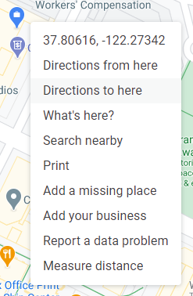
- Latitude and Longitude. Pick a key location on your project site such as the center of the restoration area, parking lot, trailhead. If your project has multiple sites, just pick one that is representative. An easy way to get the latitude and longitude is to follow these steps:
  - Open google maps and navigate to the location of your project.
  - Point the cursor at the key location you have identified (see above). On a PC right-click and select the paired numbers at the top of the list of options. These are the latitude and longitude (lat/longs). On a Mac, you get this list by using Control-Click. Selecting the numbers will copy them.
  - Paste them directly into the application. They will look something like this: 37.806155798708346, -122.27334936704644.
- Disadvantaged and Severely Disadvantaged Communities. Conservancy funding aims to prioritize projects that benefit Disadvantaged Communities (DACs) and/or Severely Disadvantaged Communities (SDACs) as defined in legislation. To determine if your project is located in one of these communities, go to this website: https://www.parksforcalifornia.org/communities/?overlays=parks. Navigate to your project location on the map. Check the legend box for Disadvantaged Community in the lower right of the map screen.

LEGISLATIVE DISTRICTS
- Districts. For each District type, list the numbers and the names of the political representatives that represent the geographical area where your project takes place.
  - State Assembly. The State Assembly works alongside the State Senate and the Governor to form the State Legislature. You can find your State Assembly member and Assembly District number at https://findyourrep.legislature.ca.gov/
  - State Senate. The State Senate works alongside the State Assembly and the Governor to form the State Legislature. You can find your State Senate member and Senate District number at https://findyourrep.legislature.ca.gov/
  - Congress. Your Congressional District represents the division of the state from which a member of the US House of Representatives is elected. You can find your Congressional District number and representative at https://www.house.gov/. Enter your project location zip code in the look up tool in the webpage’s upper right hand corner.

Project Description
The project description section is for you to explain your project to the application reviewers. Assume that the reviewers have never heard of your project and have a short time to review your application. Be concise and clear. We will use your project description to evaluate your application based on the Project Selection Criteria (see below).

- (Question 1) Site Description (1-2 paragraphs). Describe the project site or area including the location and current conditions that relate to your project. Examples include habitat types and conditions, presence of special status species, and current public access amenities. Discuss adjacent land uses if they impact the project.
- (Question 2) Project Need (one paragraph). Describe the specific problem, issue, or unserved need the project will address. In most cases, this section can be well done in one paragraph. Focus on the project and minimize discussion of broader regional issues. Examples of project need include: lack of public access, damaged or non-functional habitat, protect coastal resources, address impacts of sea level rise, improve resilience to wildfire. Do not describe in this section how the project will address that problem, issue, or unserved need.
- (Question 3) Project Activities (1-3 paragraphs). Describe specifically how the proposed project will address the project need identified above. What are the proposed activities that will be involved in the project that will solve the identified problem?
To help you understand what we are looking for, the table below provides examples of project activities for each of the project types. This is only a sample list. You should list activities that are relevant to your project whether or not they are in this table.

Type of Project | Sample Activities
Acquisition | - Acquiring land to protect it from development  - Acquiring land for future restoration and/or public access  - Acquiring a conservation easement to extinguish development rights
Planning | - Community-led planning or engagement  - Community capacity-building  - Undertake technical analyses and resource studies  - Complete conceptual or preliminary planning  - Complete CEQA environmental review  - Apply for and/or secure permits
Construction | - Remove fill or debris from a habitat area  - Breach a levee or remove a barrier to restore water flow  - Remove non-native species and replace with natives  - Build a new trail segment  - Install nature-based infrastructure or elements  - Install educational elements

- (Question 4) Project Outcomes. To the extent known, provide information on both the quantitative and qualitative project outcomes. Planning projects should use the anticipated quantitative outcomes of the project being planned. Include any community engagement related quantitative outcomes you expect your project to complete such as number of community meetings that will be held, number of volunteer events that will take place, or number of community partners that will be involved. To help you understand what we are looking for, below are examples of both quantitative and qualitative outcomes. These are only samples. You can add additional project outcomes that are relevant to your project.
Quantitative Outcomes
  - Acres of land or water protected
  - Acres of habitat restored, breakdown by habitat type if available
  - Miles of trail planned or built
  - Stream miles of spawning habitat made more accessible
  - Number of access amenities and other facilities constructed; specify what the amenities and facilities are
  - Number of community members engaged in project
  - Number of tribes engaged in project
Qualitative Outcomes
  - Habitat functions restored
  - Integration of community input into project/design plans
  - Project includes workforce development
  - Tribal access to land restored

Project Selection Criteria

The Coastal Conservancy adopted its current Project Selection Criteria on September 23, 2021 and can be found here: https://scc.ca.gov/grants/project-selection-criteria-2/. The Project Selection Criteria includes both Eligibility Criteria and Selection Criteria. The Eligibility Criteria are used for screening your project to determine if it is eligible for Conservancy funding. If your project does not meet all of the Eligibility Criteria, it is not eligible for funding. The Selection Criteria are used for project prioritization. Your project does not need to address every Selection Criteria and staff will assess each of the Selection Criteria based on your Application and the applicability for your project.

Project Eligibility Criteria (Questions 5 - 8)
Conservancy staff will determine the initial eligibility of your application based on the following criteria:

- Consistent with purposes of the funding source. Conservancy staff will confirm eligibility based on the project summary. No further response required from you (the applicant).
- Consistent with Conservancy enabling legislation, Public Resources Code, Division 21. Conservancy staff will confirm eligibility based on the project summary. No further response required from you.
- (Question 5) California Environmental Quality Act (CEQA) Compliance. The Conservancy Board must make findings relative to the California Environmental Quality Act (CEQA) when approving a project for funding. Your project must be either exempt from CEQA or the CEQA documentation must be complete before our Board considers approving the project. Acquisition and Planning projects typically are exempt from CEQA.
No further response is required from you for Acquisition and Planning projects.
For Implementation Projects Only:
  - Specify the current status of CEQA review (not started, in progress, complete). If CEQA review is not complete, specify the estimated date when it will be complete.
☐ Not Started ☐ In Progress ☐ Complete
Estimated completion date: ______________
  - What document is the CEQA review expected to result in:
☐ Exemption
☐ Negative Declaration (ND)
☐ Mitigated Negative Declaration (MND)
☐ Environmental Review Document (EIR)
☐ Addendum
  - If an ND, MND, Addendum or EIR is required, specify who the CEQA Lead Agency will be. CEQA documentation will be requested later on if the proposed project is selected to move forward with funding recommendation.
- (Question 6) Grantee capacity (1 paragraph) – Summarize your organization’s experience administering grant funds and carrying out similar types of projects and activities. You should describe past efforts that are similar in size and scope to the project you are applying for.
- (Question 7) Site ownership or control – Check the applicable box. For Acquisition projects, the “written agreement” refers to a Purchase and Sale Agreement.
☐ Applicant owns the land where the project will occur.
☐ Applicant has a written agreement with the landowner to conduct the project on their land.
☐ Applicant does not yet have a written agreement with the landowner to conduct the project on their land. If this answer is checked, specify how and when the landowner agreement will be reached.
- (Question 8) Long-term management and maintenance (1 paragraph) – Summarize the plan for the long-term management, maintenance, and monitoring of the project. Include who will be responsible for maintenance and how they will fund it.

Project Selection Criteria (Questions 9 - 12)
The following project selection criteria will be used by Conservancy staff to evaluate your proposed project. Some will be assessed from the overall application, while others are specifically asked in a numbered question.

- Extent to which the project helps the Conservancy accomplish the objectives in the Strategic Plan. Conservancy staff will assess how well your project meets one or more of the Conservancy’s Strategic Plan objectives. No further response required from you. The Conservancy’s Strategic Plan can be found here for your reference.
  - Develop the California Coastal Trail as a major recreational amenity, tourist attraction, and alternative transportation system.
  - Expand the system of coastal public accessways, open-space areas, parks, and inland trails that connect to the coast.
  - Revitalize coastal and inland waterfronts that provide significant public benefits and promote sustainable economic development.
  - Expand environmental education efforts to improve public understanding, use, and stewardship of coastal resources.
  - Protect significant coastal resource properties, including farmland, rangeland, and forests.
  - Enhance biological diversity, improve water quality, habitat, and other natural resources within coastal watersheds.
  - Enhance coastal working lands, including farmland, rangeland, and forests.
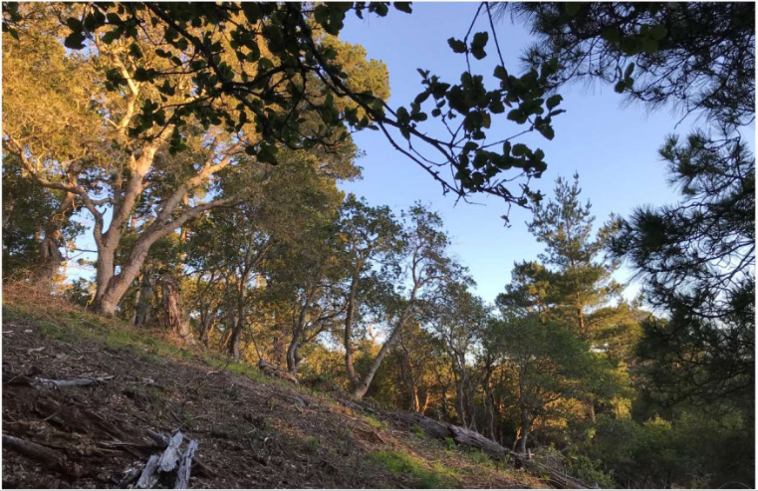
  - Enhance the resiliency of coastal communities and ecosystems to the impacts of climate change.
  - Improve public access, recreation, and educational facilities and programs within the Santa Ana River Parkway.
  - Protect and enhance natural habitats and connecting corridors, watersheds, scenic areas, and other open-space resources of regional importance in the Santa Ana River watershed.
  - Identify and prioritize long-term resource and recreational goals for the San Francisco Bay Area.
  - Protect and enhance natural habitats and connecting corridors, watersheds, scenic areas, and other open-space resources of regional importance in the San Francisco Bay Area.
  - Improve public access, recreation, and educational facilities and programs in and around San Francisco Bay, along the coast, the ridgelines, in urban open spaces, and natural areas.
  - Protect Bay Area working lands and support farmers and ranchers in implementing stewardship of the natural resources on their lands.

- Project is a good investment of state resources Conservancy staff will assess whether your projects is a good investment of state resources. No further response required from you. The list below provides key factors that we will consider in evaluating your project against this criterion:
- Project provides important benefits to Californians.
- Project is feasible.
- Budget is reasonable.
- Project leverages non state resources including volunteer work, in-kind support, or partnerships.
- Project advances statewide goals and is consistent with regional plans.
- Project protects or enhances significant resources.
- Project is located within or benefits a disadvantaged community (See disadvantaged community question above).
- Project is a pilot project that may have demonstration value.
- Applicant has consulted with relevant State and Federal agencies.
- Scientific assumptions of project are explained in the application; project follows best practices.
- (Question 9) Project includes a serious effort to engage tribes. (1-2 paragraphs). Describe how you have engaged tribes in the development of this project. The list below provides key factors that we will consider in evaluating your project against this criterion. If there is information already provided in other parts of the application, please indicate where so you don’t have to repeat it.
- Applicant has communicated with tribes as early as possible in project development, including writing letters and emails and following with phone calls updating the tribe throughout the life of the project, and meeting with local tribal government lead consortiums or other inter-tribal governmental organizations.
- Project includes working with tribes to enable traditional stewardship and cultural practices on ancestral land and co-management of their ancestral lands and natural resources; or projects assist tribes to regain access to their ancestral lands on the coast.
- Project was or will be developed with tribal leadership and perspectives, including traditional ecological knowledge, indigenous stewardship, and educational programs.
- Tribal concerns are respected, and archaeological and cultural resources are protected.
- Project provides benefits to the local tribe and its membership, including providing contracting opportunities to local tribes and their members where appropriate.
- Signage, communications, and other project information includes tribal land acknowledgement and accurate historical information.

- (Question 10) Project benefits will be sustainable or resilient over the project lifespan (1-2 paragraphs). Describe how the benefits of your project will be sustainable or resilient over the project lifespan. The list below provides key factors that we will consider in evaluating your project against this criterion. If there is information already provided in other parts of the application, please indicate where so you don’t have to repeat it.
- Project will continue to deliver benefits over a reasonable time period.
- Project will be resilient to sea level rise or other climate change impacts.
- Project will not make future climate adaptation more difficult. For example, restoring a wetland will provide benefits in the near term and may allow for other future adaptation actions.
- Applicant for planning project has identified potential implementation funding and has a strategy for obtaining necessary approvals.

- (Question 11) Project delivers multiple benefits and significant positive impact. (1-2 paragraphs). Describe how the project delivers multiple benefits and significant positive impact. The list below provides key factors that we will consider in evaluating your project against this criterion. If there is information already provided in other parts of the application, please indicate where so you don’t have to repeat it.
- Project provides co-benefits and alleviates multiple stressors within communities, such as improving public health, providing recreational amenities, reducing the pollution burden, improving flood protection, habitat enhancement or other environmental benefits.
- Project increases equity and environmental justice by benefitting underserved and/or frontline communities.
- Project increases community-preparedness or resilience to future climate change impacts such as drought.
- Project increases carbon sequestration.
- Project provides benefits to the community, such as: job training, job creation, workforce development, support for increased civic engagement, leadership development opportunities, funding for education, and volunteer opportunities.
- Urban parks, urban trails, education centers, and waterfront revitalization projects include consideration of anti-displacement strategies where appropriate. Please see Appendices for additional information.

- (Question 12) Project was (or will be) planned with meaningful community engagement and broad community support (1-3 paragraphs). Summarize how you have (or will) engaged relevant communities in the planning of this project. Also, describe the community support for this project. The list below provides examples of meaningful community engagement. We will be looking for this type of engagement in evaluating your project against this criterion. If there is information already provided in other parts of the application, please indicate where so you don’t have to repeat it.
- Engage with communities in public co-visioning processes before projects are developed to reflect community needs. Project concepts that are anchored in community priorities and expertise.
- Communities engaged in meaningful way to build mutual trust and relationships. Examples could include: 1) process involves staff, board members, or consultants who have worked in or are from respective community or 2) process includes dialogue between all affected and necessary parties, or direct involvement of local community groups.
- Engagement process addresses unequal power dynamics between communities and government, historic inequity, injustices, and trauma. Communities have a decision-making role in the development of the project.
- Community is represented on applicant’s staff, board, or within the project’s planning group, or project is partnering with local community-based organizations.
- Engagement process makes it easy for community members to participate by, for example, providing stipends, meeting in convenient locations, using virtual venues, or providing childcare and food.
- Project team has a track record working within communities and incorporating insights gained from community engagement into project planning.
- Materials developed during or as a result of the project are made available in multiple languages that are representative of the languages spoken in the engaged community.
- Question 9 pertains to meaningful community engagement with tribes, so focus this response on any engagement with other communities.

Tasks and Schedule
This section is one of the most important for communicating what the requested Conservancy grant will be used for and what will be provided to the Conservancy as a result of this work. In the Project Description section, you listed the Project Activities – a big picture summary of what will be done. In this section, you should specify the details (Tasks) of how those activities will be carried out. For each task, you should include a very brief description and list of deliverable documents (including photos and maps) that would result from the task. The tasks and deliverables vary significantly by project type. Below are some examples of how you might fill out the Tasks & Schedule table for standard acquisition, planning, and implementation projects. If your project covers more than one project type, you can use tasks and deliverables from multiple tables. You may add or remove tasks as needed to best convey your project to us. The exact tasks, descriptions, deliverables and dates in the example tables below are just examples – please fill out the table to reflect your actual project.

Acquisition Projects
 | Project Tasks | Description | Deliverables (Documents and Files) | Start Date – End Date
1 | Pre-Acquisition | Complete pre-acquisition due diligence. | - Appraisal  - Purchase and Sale Agreement  - Phase 1 Environmental Site Assessment  - Preliminary Title Report  - Draft Escrow Instructions | March 2021 – March 2023
2 | Acquisition | Complete final documents needed for closing and provide documents post-closing. | - Recorded documents  - Grant Deed  - Conservancy Offer to Dedicate or other instrument protecting the State’s investment  - Final Closing Statement | April 2023
3 | Other (Explain)

Planning Projects
For planning projects, make sure to specify the level of design that will be prepared (conceptual, 30%, 60%, final design, etc.).

 | Project Tasks | Description | Deliverables (Documents and Files) | Start Date – End Date
1 | Project Management and Administration | Activities related to grant management, managing project logistics, and funding. | - Progress reports  - Invoices | March 2021- Jan 2024
2 | Community Engagement | List anticipated methods of engagement: Outreach to find community engagement partner organizations, conducting community meetings at existing community events, social media campaign for outreach. | - Summary of community workshops and outcomes  - Slide deck and notes from community meeting | March 2021-Jan 2024
3 | Technical Studies | Conducting studies needed to inform project design, including vegetation/ ecology studies, fish monitoring, topographical surveys, hydrology and hydraulic studies, and a cultural resources study. | List studies such as:  - Baseline biological surveys  - Topographical surveys  - Hydrology and Hydraulics  - Cultural Resources | July 2021- Jan 2022
4 | Design Drawings and Specifications | Developing draft and final 30% and 60% designs | - Draft 30% designs  - Final 30% designs  - Draft 60% designs  - Final 60% designs | Dec 2021 – Jan 2023
5 | Environmental Review | Working on CEQA document | - Completed CEQA EIR | Jan 2023- Jan 2024
6 | Permitting | Early coordination with permitting agencies | - Notes from meetings with regulators | March 2024
7 | Other (Explain)

Implementation Projects
 | Project Tasks | Description | Deliverables (Documents and Files) | Start Date – End Date
1 | Project Management and Administration | Coordinating with SCC and other funders to keep them informed on progress, completing required pre-conditions, and submitting invoices. | - Progress reports  - Invoices | March 2021- Dec 2023
2 | Community Engagement | Implementing community engagement plan throughout the project, prepping for and hosting community meetings for outreach, hosting volunteers for restoration planting. | - List of restoration volunteers and hours worked  - Notes from 3 community meetings | April 2021-October 2021
3 | Final Design and Permitting, if applicable | Developing plans, specs and estimates and completing permitting | - 100% designs, including plans, specs & estimates  - Completed permits | March 2021-May 2021
4 | Construction Management | Construction management consultant will administer the construction contract and perform inspections | - Copy of awarded Construction Management firm contract & invoices | May 2021- November 2021
5 | Construction Cost (attach engineer’s cost estimate or other detailed cost estimate) | Construction of public access and restoration features. | - Contractor invoices  - As-built plans, before/during/after photos, installed funding sign | May 2021-November 2021
6 | Environmental Compliance (if not included above) | Conducting required monitoring and trainings throughout construction per CEQA requirements | - Copies of archaeological monitoring plan, biological resource sensitivity training materials, post construction biological monitoring plan | April 2021-November 2021
7 | Monitoring and Adaptive Management | Monitoring after construction completion for 2 years to determine need for any change in management actions | - Copy of monitoring reports | December 2021 – December 2023
8 | Other (Explain)

Permits
Planning and Implementation projects only. Check the permits needed to undertake the project. Links to permitting information are provided in the table below.

Name of permit | Secured | Pending | Included in Scope of Application
☐ Coastal or Shoreline Development Permit | ☐ | ☐ | ☐
☐ Local Grading, Vegetation, or Other permit  Contact your local County/City planning department | ☐ | ☐ | ☐
☐ CDFW Lake/Streambed Alteration Permit (1600) | ☐ | ☐ | ☐
☐ CDFW California Endangered Species Act Take Authorization | ☐ | ☐ | ☐
☐ Regional Water Quality Control Board Certification (401) | ☐ | ☐ | ☐
☐ U.S. Army Corps 404 or 408 Permit | ☐ | ☐ | ☐
☐ U.S. Fish and Wildlife Service Biological Opinion | ☐ | ☐ | ☐
☐ National Marine Fisheries Service Biological Opinion | ☐ | ☐ | ☐
☐ Other – Please specify | ☐ | ☐ | ☐

Project Cost Estimate
The project cost estimate should provide the current estimated project cost and should indicate how you anticipate applying the Conservancy grant to those costs. Note, we understand that the amount of each task may change between when you apply for a grant and when you receive the grant. We also understand that how you want to allocate the Conservancy’s grant, if awarded, may also change. If you are awarded a Conservancy grant, we will work with you to address necessary budget changes.

Fill in the Project Cost Estimate table in the application, matching the tasks in the Project Cost Estimate table with the tasks you’ve listed in the Task and Schedule table from the previous section. Below are some examples of budget tables that match the example Task and Schedule tables above.

The Planning and Implementation project budget templates include a category for indirect costs. Indirect costs for the whole project should be shown on this line item, rather than applied to each task. Your indirect cost rate can be whatever rate has been appropriately calculated for your organization. For more information on calculating your indirect rate, your organization should contact a Certified Public Accountant that works with nonprofit or government organizations. Note that, regardless of the rate that is used, the total amount of indirect costs charged to the Conservancy cannot be more than 20% of the total grant amount. Acquisition projects do not typically include indirect costs.

Please round all budget numbers up to the nearest $100.

In the Budget Justification section, you should provide an explanation of the costs for each of the project tasks that will be charged to the Conservancy grant. The budget justification should give reviewers a sense of what costs each budget line item will cover. Please list by task what the cost breakdown is, including estimated labor hours, any materials that will be purchased, or additional costs that your project will have. You can read more about what costs the Conservancy can cover in our grants in Section III of this guide on Eligible Costs.

Project Cost Estimate: Acquisition Projects
 | Project Cost Estimate: Acquisition Project Tasks | Conservancy Grant | Other Funding | Total
1 | Pre-Acquisition Costs
2 | Acquisition  Acquisition Price  Closing Costs  Other
 | TOTAL

Budget Justification (Only required for costs listed under Conservancy Grant)
- Pre-Acquisition Costs: List the pre-acquisition costs included in the cost estimate.
- Acquisition Price – Specify the basis of the acquisition price (appraisal, estimate based on similar acquisition, etc.)
- Closing Costs: List the closing costs included in the cost estimate.
- Other – Identify any other costs included in the cost estimate.

Project Cost Estimate: Planning Project
 | Project Tasks | Conservancy Grant | Other Funding | Total
1 | Project Management and Administration
2 | Community Engagement
3 | Technical Studies (List)
4 | Design Drawings and Specifications
5 | Environmental Review
6 | Permitting
7 | Other
 | Indirect Costs
 | TOTAL

Budget Justification (Only required for costs listed under Conservancy Grant)
- Community Engagement – Provide approximate number of hours of your staff’s time that will be charged to the Conservancy for Community Engagement, and separately provide the approximate number of hours of consultant time. You can include stipends for community participation or hours for community partners that will be compensated as well.
- Technical Studies -- List the technical studies that will be undertaken and the approximately cost of each. Specify the basis of this estimate (consultant proposal, estimate based on past experience, etc.).
- Design Drawings and Specifications – If more than one level of design (for example, 30% and 60%) will be prepared, provide the cost estimate for preparing each level. Specify the basis of this estimate (consultant proposal, estimate based on past experience, etc.).
- Environmental Review – Specify the basis of this estimate (consultant proposal, estimate based on past experience, etc.).
- Permitting – If the estimated cost of work related to any individual permit is $10,000 or more, provide that individual cost estimate in this justification.
- Other – Specify the components of the “Other” category and the basis of the cost estimate. If the estimated cost for any individual component in the “other category” is $10,000 or more, provide that individual cost estimate in this justification.

Project Cost Estimate: Implementation Project
 | Project Tasks | Conservancy Grant | Other Funding | Total
1 | Project Management and Administration
2 | Community Engagement
3 | Final Design and Permitting, if applicable
4 | Construction Management
5 | Construction Cost (attach engineer’s cost estimate or other detailed cost estimate)
6 | Environmental Compliance (if not included above)
7 | Monitoring and Adaptive Management
8 | Other
 | Indirect Costs
 | TOTAL

Budget Justification
In this budget justification section, you only need to address the costs listed under Conservancy Grant.
- Project Management and Administration -- Provide approximate number of hours of your staff’s time that will be charged to the Conservancy for Project Management and Administration, and separately provide the approximate number of hours of consultant time.
- Final Design and Permitting – Specify the basis for the Final Design and Permitting cost estimate; for instance, estimate from designer, estimate based on similar past experience, etc.
- Construction Management (CM) – Specify the basis for the CM cost estimate; for instance, percent of construction cost, estimate from CM contractor, etc.
- Construction Cost -- Specify the basis of the construction cost estimate, including the level of design(%) that the estimate is based on. Specify the contingency costs included in the cost estimate (note: we will pay for contingency costs, no need to hide them).
- Environmental Compliance – Specify the main components of the environmental compliance work such as biological and cultural monitoring, implementing mitigation measures not included in the Construction Cost, implementing required habitat mitigation if not included in the Construction Cost. Specify the basis of the cost estimate for this task.
- Monitoring and Adaptive Management – Specify the components of the monitoring and adaptive management work and the basis of the cost estimate. Note that the Conservancy can usually only pay for 0 to 2 years of post-project monitoring and adaptive management due to time constraints on our funding.
- Other – Specify the components of the “Other” category and the basis of the cost estimate. If the estimated cost for any individual component in the “other category” is $10,000 or more, list that individual cost estimate in this justification.

Project Maps, Design Plans, and Photos

Project Location Map
Include a map that clearly shows the project location within the context of the surrounding area. Be sure map shows nearest road access to site.

Concept Level Site Plan
For all Implementation projects and those Planning projects where conceptual design work has been completed, you should include a conceptual level site plan showing the key project components. For Implementation projects, more detailed design documents can also be provided as an attachment.

Site Photos
Provide one or more clear photos of the project site that clearly show the character of the site.

Additional Documents
If there are any additional documents that are critical for understanding the project, please attach or provide a link(s) for up to two additional documents. Examples of attachments could include feasibility studies, CEQA documents, appraisals, or other documents that are directly related to the proposed project.

Non-Profit Applicant Documentation
Non-profit applicants should include the following with the applications:
- Completed Nonprofit Organization Pre-Award Questionnaire.
- Letter of Determination from the Internal Revenue Service indicating current 501(c)(3) status.
- Note: Applicants who have submitted the questionnaire in the past two years do not need to resubmit. Non-profits only need to submit the 501(c)(3) letter once, unless it is updated.

Conservation Corps Consultation Process
For Implementation projects, applicants must submit a completed Conservation Corps Consultation Review Form.

Southern California Wetlands Recovery Project
For wetlands restoration projects on the Southern California Wetlands Recovery Project Work Plan, submit a map of your project site using the Marsh Adaptation Planning Tool (MAPT) and your WRP Support Letter.

Grant Application Survey
The Conservancy seeks to continuously improve our grant application process. Please take some time after completing this grant application to provide feedback on your experience as an applicant. The survey link can be accessed here. Your response will be anonymous, and we will greatly appreciate your constructive criticism.

Eligible Costs
This section provides rules and examples of eligible costs for Acquisition, Implementation and Planning projects.

Acquisition Project Eligible Costs
The following table provides examples of Eligible Costs for Acquisition Projects.

Acquisition Costs | Examples
Purchase price of the property and other activities necessary to complete the Acquisition.  To be eligible for a Conservancy grant, property must be acquired from willing sellers. Acquisition costs associated with condemnation or eminent domain are not eligible. In addition, the land’s sale price may be up to, but cannot exceed, the appraised fair market value. State funds may not be used in part or whole to acquire property above fair market value. | - Appraisals, surveys  - Preliminary title reports  - Title insurance fees  - Escrow fees and purchase price, at no more than fair market value  - Project Management Costs

Planning Project Eligible Costs
Planning Project Costs | Examples
Data collection, technical analyses, design and engineering, environmental review, permitting, management activities, community engagement necessary to complete the planning effort. | - Community-based planning meetings, focus groups, design workshop costs. May include multi-lingual translation, materials, stipends for community members’ time, etc.  - Online community engagement tools  - Data collection and analysis  - Modelling and other technical analyses  - Environmental Review (CEQA and NEPA)  - Work necessary to secure project permits  - Development of a bid packages  - PROJECT/GRANT administration (excluding grant writing) and accounting

Implementation Project Eligible Costs
The following table provides examples of Eligible Costs for Implementation Projects.

Implementation Project Costs | Examples
Final design and permitting activities, construction activities and associated regulatory compliance, and management activities necessary to complete the project. | - Project Management and Grant Administration  - Community Engagement meetings and activities, including participant or partner stipends.  - Plans, specifications, construction documents, and cost estimates  - Permits  - Premiums on hazard and liability insurance to cover personnel or property  - Bid package development  - Site preparation, grading, gutting, demolition  - Purchase and installation of permanent structures: bridges, bathrooms, etc.  - Construction supplies and materials  - Construction equipment owned by GRANTEE: Daily rates for equipment owned by the grantee may be charged to the grant for each use. Rental rates published by the California Department of Transportation may be used as a guide. For audit purposes, a report or source document must describe the work performed, indicate the hours used, relate the use to the GRANT SCOPE, and must be signed by the operator or supervisor.  - Construction equipment rented or purchased by GRANTEE: equipment may be rented or purchased, whichever is the most economical use of GRANT funds. For purchased equipment, the GRANT will pay for the rental price equivalent in proportion to the time the purchased equipment is used on the GRANT SCOPE. (Rental rates published by the California Department of Transportation may be used as a guide.) The GRANT will pay for the total cost of the equipment if the purchase price is less than the rental price equivalent. Any funds earned by the GRANTEE from the sale of equipment purchased with the GRANT must be spent on the PROJECT.  - Construction management: including site inspections, scheduling mobilization, directing equipment, materials, and construction personnel.  - Miscellaneous costs: other costs incurred during the construction phase, such as transporting materials, equipment, personnel, communications and landscape establishment periods.  - Contingency costs.

Ineligible Costs
Ineligible costs include, but are not limited to, the following:

- Costs incurred before the grant agreement is signed and preconditions met or after the grant completion date.
- Projects imposed on an Applicant through legal mitigation or a regulatory process. Note, the mitigation costs associated with implementation of a project are eligible costs.
- Fundraising
- Food for meetings or events (Can be eligible in certain situations, inquire with the Regional Manager if food for events is necessary for your project.)
- Grant Writing in most cases
- Operation and Maintenance
- Addressing record keeping discrepancies
- Charging employee services without documentation (timesheets) of actual time spent on the project
- Other charges that lack source documents or backup documentation (no evidence of invoices, bid process, payment receipts, etc.)

Appendices

Technical Assistance for Applicants
This section summarizes the assistance available to Applicants. We encourage you to access the following:

Individual Assistance
All Applicants can request a technical assistance meeting with Conservancy staff. We encourage you to consult with us prior to applying. In these meetings, we will answer any questions you have and provide guidance on how to make your application as competitive as possible. To schedule a meeting, send an email with a brief description of your project to the Regional Manager that covers the location of your project:

North Coast: Del Norte County to coastside Sonoma and Marin Counties
Karyn Gear: karyn.gear@scc.ca.gov

San Francisco Bay Area: Nine Bay Area Counties, excluding the coastside of Sonoma, Marin, and San Mateo Counties
Moira McEnespy: moira.mcenespy@scc.ca.gov

Central Coast: Coastside San Mateo County to Santa Barbara County
Trish Chapman: trish.chapman@scc.ca.gov

South Coast: Ventura County to San Diego County, plus Riverside and San Bernardino counties.
Megan Cooper: megan.cooper@scc.ca.gov

Grant Writing Training
In 2016, the Conservancy offered a training to “Improve Your Grant Writing Skills”. The recording of this webinar provides helpful guidance on how to write strong grant applications. We recommend you watch this video: https://youtu.be/bnR8KPTnWvc

Parks-Related Anti-Displacement Strategies
The SCC’s mission includes helping people access and enjoy the outdoors. Projects such as parks, urban greenspaces, trails, education centers, and waterfront revitalization provide multiple benefits ranging from local economic development to positive health outcomes. However, these well-intentioned projects sometimes result in drastic increases in property values in the immediate neighborhoods where they occur and can raise the risk of displacement for residents, their respective cultures, and local businesses.

The following flowchart was created by Conservancy staff to assist grantees in considering Parks-Related Anti-displacement Strategies:

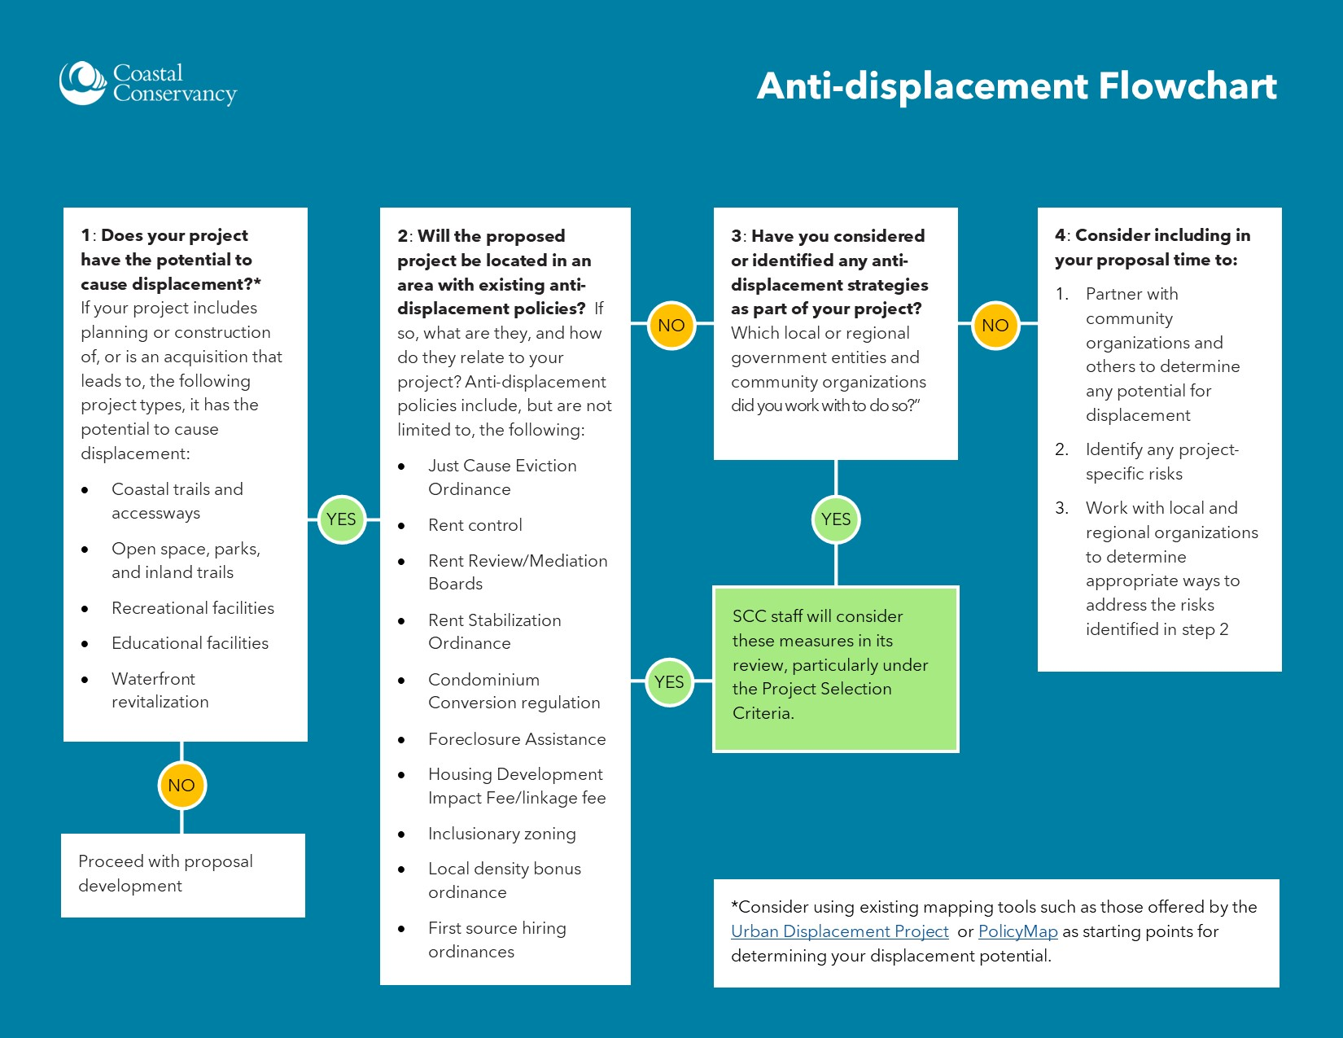

Assistance with Incomplete Application Documents
The Conservancy does not automatically disqualify an Application if it is missing a required element. In these cases, the Conservancy will request the missing information and provide a deadline for submittal. If multiple parts of the application are missing it will be deemed ineligible.

Strengths and Weaknesses
If you project does not receive a grant award, you can get “strengths and weaknesses” feedback based on the Project Selection Criteria once all decisions have been made. This feedback may be useful to you in applying for funding in the future. Please contact the appropriate Regional Manager (see list above) to discuss your project.

